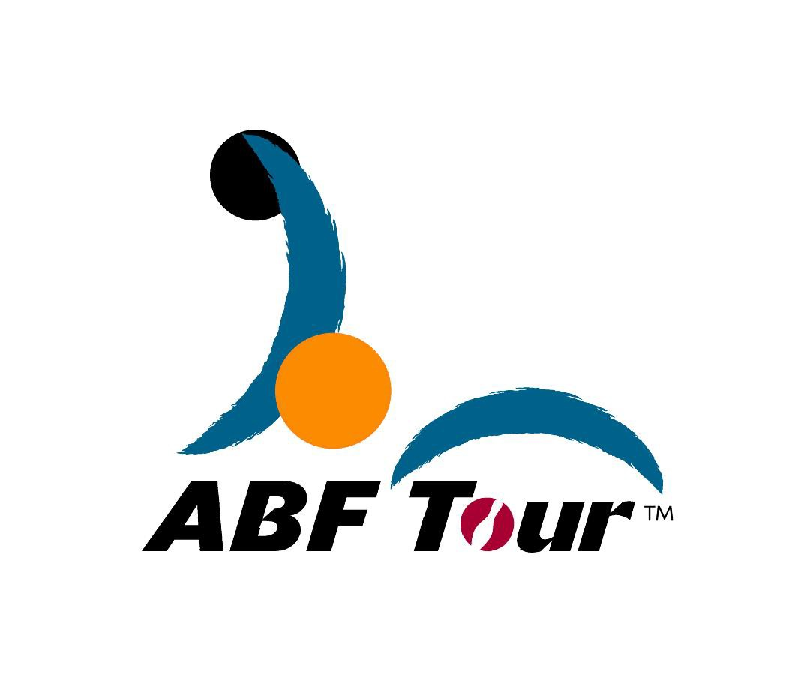
ABF TOUR 2017
Hong Kong leg

Reply Slip for Intention of Participation
(To be completed and returned to the tournament secretariat before bowling your first game)

To : ASIAN BOWLING FEDERATION

From :
(Name of bowler)

(Country)

I have read the attached rules and regulations for the ABF Tour.

I * Intend to participate in the ABF TOUR HONG KONG 2017

* DO NOT intend to participate in the ABF TOUR HONG KONG 2017

*Please whichever is appropriate.

Signature:

Date

Signature of Bowler

