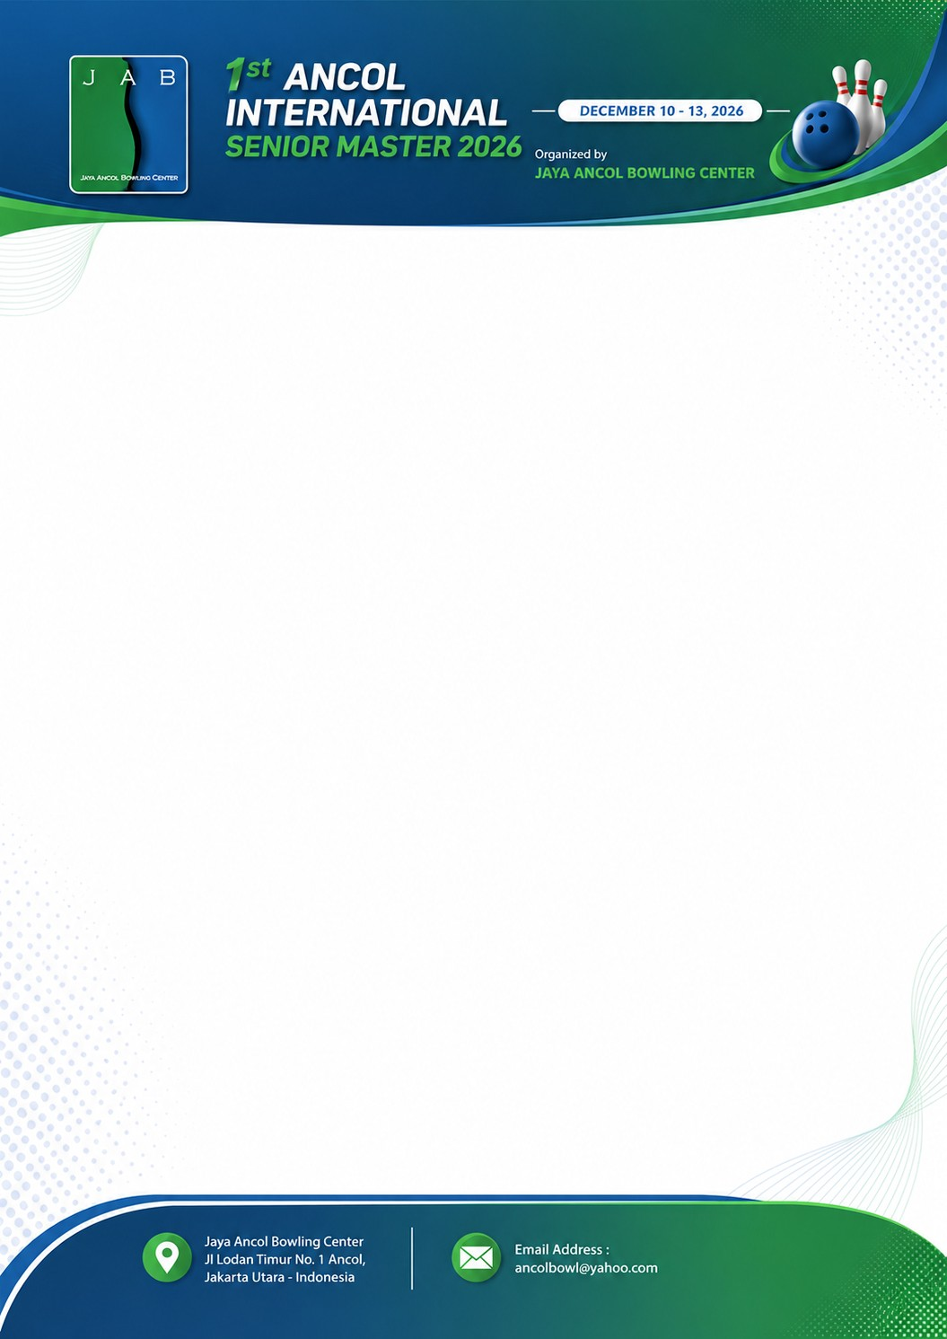

Hotel Room Accommodation Form

Reservation Name :
City / Country :
Contact Number :

Reservation
Hotel | Discovery Ancol Hotel
Number of rooms:
Check In Date:
Check Out Date:
Rate: per room per night | Deluxe Room (2 people) | IDR 900,000 net (approx. US$ 52)
Rate: per room per night | Extra Bed (per bed per person) | IDR 500,000 net (approx. US$ 28)

Room Accommodation Name of Guest(s)
Check In Date : | Room Number 1
 | Guest 1 :
Check Out Date : | Guest 2 :
 | Etra Bed :

Check In Date : | Room Number 2
 | Guest 1 :
Check Out Date : | Guest 2 :
 | Etra Bed :

Check In Date : | Room Number 3
 | Guest 1 :
Check Out Date : | Guest 2 :
 | Etra Bed :

Please submit this form with personal digital photo and copy of each guest passports to be used as accreditation and credentials to avail of the Park Facilities.
Deadline for Submission: October 20th, 2026

