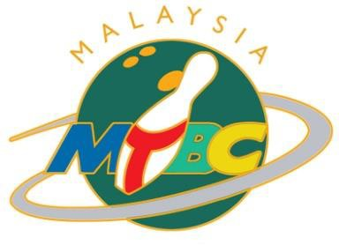
MALAYSIAN TENPIN BOWLING CONGRESS
c/o Sunway Mega Lanes, Lot F2.22, Level 1, Sunway Pyramid, 3 Jalan PJS 11/15, Bandar Sunway 46150 Petaling Jaya
Tel: 603-74923226 Fax : 603-74923227 Email : administrator@mtbc.org.my

FORM A

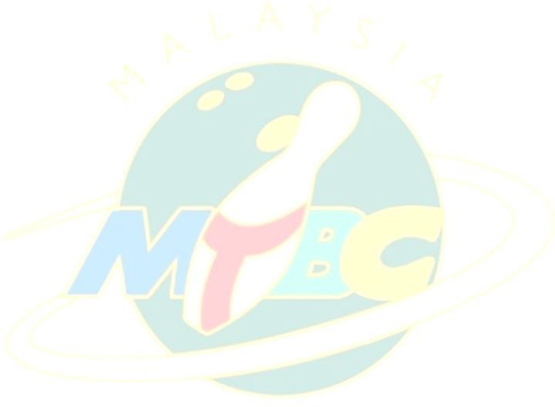
23RD ASIAN JUNIOR TENPIN BOWLING CHAMPIONSHIP 2024
16 – 23 JUNE 2024, MALAYSIA
INTENTION OF PARTICIPATION REPLY SLIP
(To be completed and returned to MTBC on or before 15 MARCH 2024)
To: Malaysian Tenpin Bowling Congress
Email: administrator@mtbc.org.my
(with the email subject header as “AJC 2024 [Country Name]”)
Re : 23rd Asian Junior Tenpin Bowling Championships (16 – 23 June 2024)
- *We intend to participate in the 23rd Asian Junior Tenpin Bowling Championships
- *We do not intend to participate in the 23rd Asian Junior Tenpin Bowling Championships
*Please  whichever is applicable.
From
(Name of Federation)

- Boys’ Team | - *One | - *Two (Maximum of 2 Boys’ Team)
- Girl’s Team | - *One | - *Two (Maximum of 2 Girls’ Team)

Signature : Seal : President or Secretary General
of the federation

Date :

TOGETHER WE SERVE TO BETTER OUR SPORT
P a g e | 1

