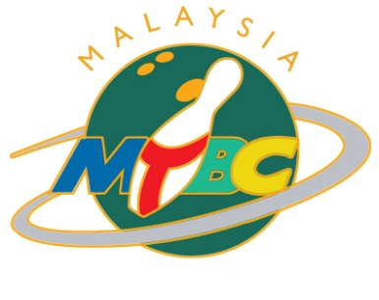

**MALAYSIAN TENPIN BOWLING CONGRESS**c/o Sunway Mega Lanes, Lot F2.22, Level 1, Sunway Pyramid,   
3 Jalan PJS 11/15, Bandar Sunway 46150 Petaling Jaya  
Tel: 603-74923226 Fax : 603-74923227 Email : administrator@mtbc.org.my

**FORM A**

**2ND ASIAN PARA TENPIN BOWLING CHAMPIONSHIP 2025  
30 AUGUST – 6 SEPTEMBER 2025, MALAYSIA**

**INTENTION OF PARTICIPATION REPLY SLIP**

**Please complete and return this form to Malaysian Tenpin Bowling Congress**[malaysianbowling@gmail.com](mailto:malaysianbowling@gmail.com) on or before **31 MARCH 2025**  
*(with the email subject header as “APC 2025 [Country Name]”)*

|  |  |
| --- | --- |
| NATIONAL FEDERATION |  |
| CONTACT PERSON |  |
| PHONE |  |
| EMAIL ADDRESS |  |

**Please (✓) where appropriate**

* *We **intend** to participate in the 2nd Asian Para Tenpin Bowling Championships 2025

**ENTRY BY NUMBERS:-**

|  |  |  |  |  |  |  |
| --- | --- | --- | --- | --- | --- | --- |
| Event | Category | No. of Entries | | Category | No. of Entries | |
| **SINGLES** | Men | Women | Men | Women |
| TPB1 |  |  | TPB8 |  |  |
| TPB2 |  |  | TPB9 |  |  |
| TPB3 |  |  | TPB10 |  |  |
| TPB4 |  |  |  |  |  |

|  |  |  |
| --- | --- | --- |
| Event | Category | No. of Entries |
| **DOUBLES** | TPB1 + TPB3 |  |
| TPB2 + TPB2 |  |
| TPB4 + TPB4 |  |
| TPB8 + TPB8 |  |
| TPB9 + TPB9 |  |
| TPB10 + TPB10 |  |
| **TRIOS** | TPB1 + TPB1/2 + TPB2/3 |  |
| TPB8 + TPB8/9 +TPB9/10 |  |
| TPB4 + TPB4 +TPB4 |  |

* *We **do not intend** to participate in the 2nd Asian Para Tenpin Bowling Championships 2025

Signature : Seal :

President or Secretary General  
of the federation

Date :